EE5355_DISCRETE TRANSFORMS AND APPLICATIONS

SLANT TRANSFORM

NAME: PAVAI ARCHIMEDES

ST ID: 1001233996

PROGRAM:

clc;

clear all;

close all;

I1=imread('C:\Users\PAVAI ARCHIMEDES\Desktop\lena512.bmp');

I=double(I1);

S=sltmtr(3);

p=0.9;

for i=1:8

for j=1:8

c(i,j)=p^abs(i-j);

end

end

c_t=S*c*S';

[M,index]=sort(c_t(:),'descend');

m1=zeros(64,1);

for i=1:16

m1(index(i))=1;

end

m2=zeros(64,1);

for i=1:11

m2(index(i))=1;

end

m3=zeros(64,1);

for i=1:8

m3(index(i))=1;

end

m1=reshape(m1,[8 8]);

m2=reshape(m2,[8 8]);

m3=reshape(m3,[8 8]);

for i=1:8:512

for j=1:8:512

temp=S*I(i:i+7,j:j+7)*S';

s1=temp.*m1;

s1_r(i:i+7,j:j+7)=S'*s1*S;

s2=temp.*m2;

s2_r(i:i+7,j:j+7)=S'*s2*S;

s3=temp.*m3;

s3_r(i:i+7,j:j+7)=S'*s3*S;

end

end

mse1=sum(sum((I-s1_r).^2))/(512*512);

mse2=sum(sum((I-s2_r).^2))/(512*512);

mse3=sum(sum((I-s3_r).^2))/(512*512);

psnr1=10*log((255^2)/mse1);

psnr2=10*log((255^2)/mse2);

psnr3=10*log((255^2)/mse3);

disp(mse1);

disp(mse2);

disp(mse3);

disp(psnr1);

disp(psnr2);

disp(psnr3);

subplot(2,2,1);

imshow(uint8(I1));

title('Original image');

subplot(2,2,2);

imshow(uint8(s1_r));

title('4:1 sample reduction');

subplot(2,2,3);

imshow(uint8(s2_r));

title('6:1 sample reduction');

subplot(2,2,4);

imshow(uint8(s3_r));

title('8:1 sample reduction');

RESULT:

The MSE between original and reconstructed images using 4:1 sample reduction, 6:1 sample reduction and 8:1 sample reduction are shown below.

1.2111e+003 913.1628 645.3731

The PSNR values for images reconstructed using 4:1 sample reduction, 6:1 sample reduction and 8:1 sample reduction are shown below.

39.8320 42.6561 46.1270

The original image and the images reconstructed using 4:1 sample reduction, 6:1 sample reduction and 8:1 sample reduction are shown below

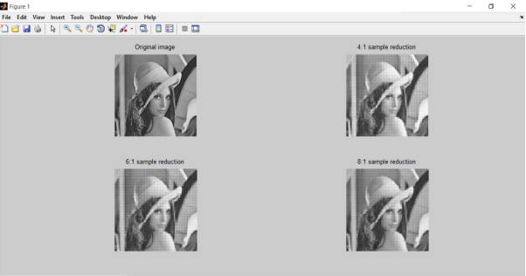

INFERENCE:

The higher PSNR gives better quality in the reconstructed image.